1. LSTM fitting for long cycles

Machine 01M01 was used, one-tenth of the data are selected, while range = [102119:230358].

Two-layer LSTM was used, first layer 128 nodes, second layer 64 nodes. Epochs = 200, batch size = 128.

The PHM leaderboard error was used for evaluating the prediction.

Notification: in this trend, the smallest ttf is 27590, which is not close to 0, so the error is small.

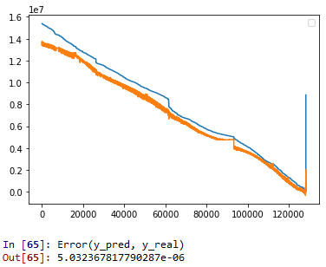

1. LSTM for short cycles

Machine 01M01 was used, one-tenth of the data are selected, while range = [35499:37778].

Two-layer LSTM was used, first layer 64 nodes, second layer 32 nodes. Epochs = 50, batch size = 32.

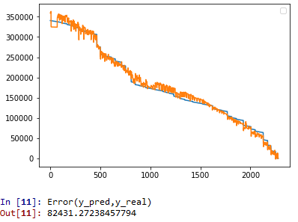

1. LSTM for average cycles

Machine 01M01 was used, one-tenth of the data are selected, while range = [42050:75436].

Two-layer LSTM was used, first layer 128 nodes, second layer 64 nodes. Epochs = 50, batch size = 128.

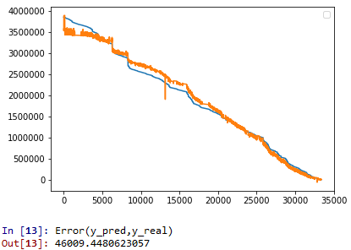

1. LSTM fitting for tail data

Data range 01M01 [754000: 754360] (no data reduction)

Three layer LSTM (16, 16, 16), epochs = 200, batch_size = 16

